Muller Martini RB5 Cover Feeder Instructions

Aligning the Creasing units
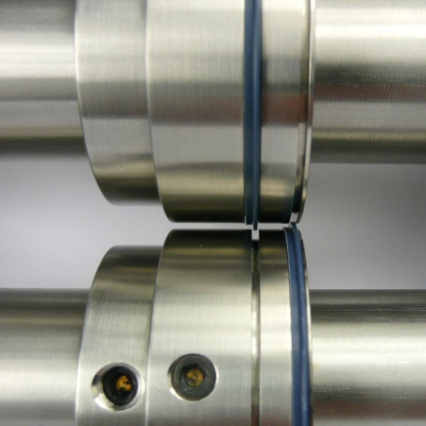
With the crease ribs locked into the crease units, align the BOTTOM SHAFT crease units to the correct creasing position (left-side being aligned with the edge of the book clamp ) and tighten the fixing screws.

Slowly lower the top shaft making sure the crease ribs locate into the female channel on the bottom crease unit.

DO NOT TIGHTEN TOP SHAFT FIXING SCREWS.
Slowly run a sheet of cover stock through the Spine & Hinge units.
As the cover travels through the crease units the loose top crease units will automatically centralise to the optimum creasing position.
With the cover stock still gripped between the crease units tighten the fixing screws.
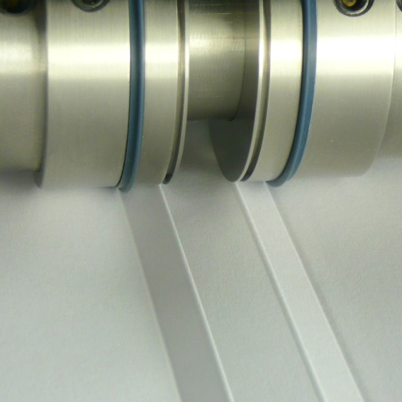
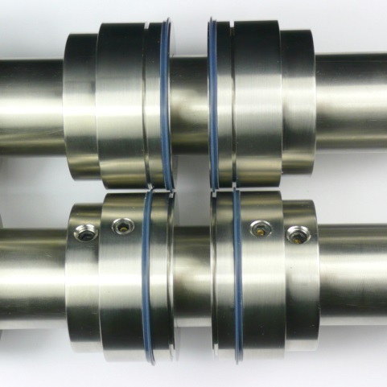


The machine is now ready to test

